HORN & LAURETTI
225 FRIEND STREET, SUITE 204

BOSTON, MA 02114
(617) 589-3000

FAX (617) 523-3812
JOHN M. HORN DENISE M. LAURETTI*
MICHAEL S. KINSON* JEFFREY D. SWARTZ

*Admitted in MA and NH

Peter T. Toland, Esquire
LaRosa/Toland Law Offices
3 Baldwin Green Common Suite 207
Woburn, MA 01801

RE: Frost v. Criscuolo, et al
Middlesex County Middlesex Superior Court Division Civil Action No.: 08-4065

Dear Attorney Toland:

Attached pursuant to Rule 30 and Rule 45 of the Massachusetts Rules of Civil Procedure, is a copy of the Keeper of Records Notice of Taking Deposition and Subpoena for the following locations and relating to the above-captioned matter:

Fallon Community Health Plan (Insurance Records)

Thank you for your attention to this matter.

Very truly yours,
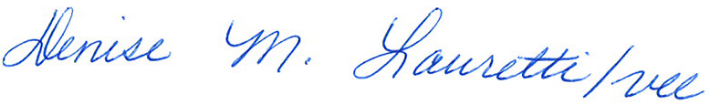

John M. Horn

DML/vll
Enclosure
Cc: John M. Horn and William Morley

Order No. 01-17231-010

Staff Counsel: Hanover Insurance Company/Citizens Insurance Company
Not a Partnership

